Introduction :

  - Project Overview: In today’s data-driven world, electricity consumption analysis plays a vital role in energy planning and policy-making. Government agencies and electricity boards collect vast amounts of consumption data, but without proper visualization tools, extracting meaningful insights becomes difficult.
The project titled “Plugging into the Future – Electricity Consumption Analysis Using Tableau” focuses on analyzing electricity usage across states, regions, months, quarters, and years (2019 & 2020).
Using Tableau, raw electricity datasets are transformed into interactive dashboards that help answer key questions:
- Which states consume the most electricity?
- How did lockdown impact electricity demand?
- What are the seasonal and regional trends?
- Which regions dominate overall power usage?
The dashboard enables interactive filtering and drill-down, providing a complete analytical view for energy stakeholders.
  - Purpose: The purpose of this project is to support data-driven energy planning by visualizing electricity consumption patterns across:
- State-wise usage
- Region-wise comparison
- Monthly and quarterly trends
- Lockdown impact analysis
- Top and Bottom consuming states
The solution simplifies complex datasets into intuitive dashboards that allow policymakers and energy officials to make faster, evidence-based decisions.

IDEATION PHASE :
  - Problem Statement: Electricity boards struggle to analyze large state-wise and time-based datasets using static spreadsheets.
Challenges include:
- Difficulty identifying peak demand periods
- Lack of regional comparison tools
- No interactive filtering capability
- Limited visibility of lockdown impact

There is a need for an interactive visualization solution that connects stakeholders directly to their data.

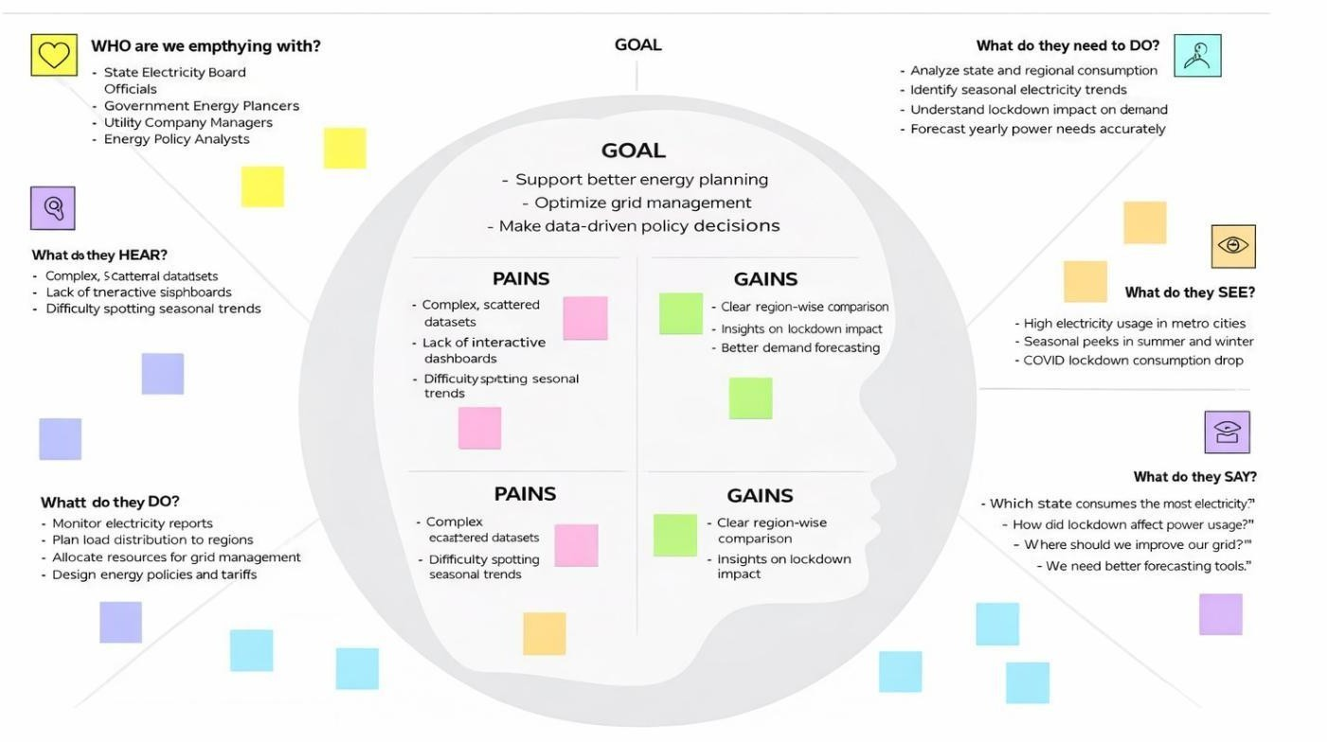
Empathy Map Canvas :

  - Brainstorming :
    - Team Collaboration and Approach: Our team began the project with a brainstorming session to analyze the electricity consumption dataset and identify key variables such as State, Region, Year, Quarter, and Usage.
We discussed suitable visualizations like maps, bar charts, and line charts to effectively present insights. Responsibilities were divided among data cleaning, calculated field creation, dashboard design, and story development.
We followed an Agile approach with regular reviews to ensure clear visuals, proper interactivity, and timely project completion.

    - Ideas Generated and Grouped by Category:
- Key Ideas Generated:

Idea | Category
State-wise comparison map | Geographic Analysis
Quarter-wise usage trend | Seasonal Analysis
Lockdown impact comparison | Event Impact Analysis
Top N & Bottom N states | Ranking Analysis

Region-wise pie chart |  |  | Regional Distribution
Interactive filters |  |  | User Interactivity
Tableau Story feature |  |  | Presentation
2.3.3. Prioritization:
 | Priority | Idea | Reason
 | High | Bar Chart for Product  Position vs Sales | Core to solving the project’s main problem
 | High | Donut Chart for Promotion  Impact | Simple and clear to stakeholders
 | Priority | Idea | Reason
 | High | Highlight Table for Demographics | Helps target customer segments more precisely
 | High | Filters for Category, Traffic, and Promotion | Essential for interactivity
 | Medium | Funnel and Waterfall Charts | Adds depth to financial and behavioral insight
 | Low | Word Cloud and Storyboard | Adds polish and storytelling but not critical to logic

REQUIREMENT ANALYSIS :
  - Customer Journey map : The Customer Journey Map helps visualize the enduser’s experience from problem identification to solution adoption. For this project, our primary users are retail managers, marketing analysts, and store planners who want to improve sales using data-driven product placement.

Customer Journey Map
Dashboard
Stage User Action Pain Point Solution

Awareness
Notices inconsistent
power demand Static reports
Interactive dashboard

Analysis
Tries manual Excel
analysis Time-consuming Filters & charts

Insight Identifies peak demand Hard to compare data Quarter & Month
charts
Dashboard
Stage User Action Pain Point Solution
Action Plans resource allocation Needs presentation Tableau Story &

support
Export

Solution Requirement:
Functional Requirements
    - Upload electricity dataset
    - Clean and preprocess data
    - Create state map and charts
    - Add filters (Year, Region, Quarter, State)
    - Build Top N & Lockdown analysis
    - Enable export functionality

Non-Functional Requirements
    - Usability – Easy to navigate
    - Performance – Load within 5 seconds
    - Reliability – Accurate filter results
    - Scalability – Support future years
    - Availability – Accessible via Tableau Public

  - Data Flow Diagram: A Data Flow Diagram (DFD) shows how data moves through your system — from input to final output — across different components. This project processes a CSV dataset through Tableau to produce interactive dashboards for business decision-making.
Level 1 DFD – Detailed Process Flow:
 | Process Component | Description
1 | Data Input | User uploads Product Positioning.csv to Tableau

2 | Data Cleaning &  Formatting | Missing value check, column type conversion, column renaming
3 | Calculated Fields | Fields like Price Gap, Sales Category, % Difference
4 | Visualization Engine | Tableau sheets and dashboards created using multiple chart types
 | Process Component | Description
5 | Filters | Applied on Promotion, Traffic, Demographics,  Product  Category
6 | Dashboard Assembly | All sheets combined into one interactive dashboard
7 | Storytelling Mode | Tableau story created to walk stakeholders through key insights
8 | Output | Users view or export dashboard results (PDF, image, or shareable link)

  - Technology Stack: This section outlines the tools, technologies, and components used to build and deploy the solution. It includes both the architecture layers and the technology choices for your project.
- Technical Architecture (3-Tier Design)
Layer Component Description

Presentation Layer
The final Tableau Dashboard UI, visible to users. Includes interactive filters and visuals

Application Layer
Tableau Engine responsible for creating calculations, visual logic, and rendering visuals

Data Layer
Raw dataset: Product Positioning.csv stored locally or on Google Drive

- Components & Technologies Used

S.
Component Description Technology Used
No
Tableau Dashboard with visual Tableau Public /
1 User Interface
and filter components Desktop

Data cleaning, type conversion, Tableau, Optional:
2 Data Processing
and calculated fields Python/Pandas

Dataset stored and imported into Local File System /
3 File Storage
Tableau Google Drive

Visualization Tableau Visualization
4 Chart rendering and
interactivity
Engine Engine

Story Tableau Story feature for
5 Tableau
Presentation sequential insights

Export & Export reports in PDF/Image Tableau Public / PDF
6
Sharing formats; public dashboard access Export

- Application Characteristics

Feature Description Technology Used

Open Source Frameworks
Tableau Public is freely accessible, optional use of Python (Pandas)
Tableau Public, Pandas

Security Controlled data sharing via Tableau Public permissions and Google Drive
Tableau Share Settings

Scalability
Can support more data rows, product lines, or new categories easily
Tableau Extract Engine

Feature Description Technology Used

Availability Hosted via Tableau Public or downloadable
as a file for 24/7 access
Tableau Public

Performance
Fast loading for up to 1000+ rows with live filters and dashboard response
Tableau (Live / Extract)

PROJECT DESIGN:

Problem Solution Fit:
The Problem
Our product is an interactive Tableau dashboard that analyzes electricity consumption across states and regions for 2019 and 2020.
It provides insights into monthly trends, quarterly usage, lockdown impact, and Top/Bottom consuming states using dynamic filters and visual storytelling for better energy planning decisions.

The Solution
This project proposes a fully interactive Tableau dashboard that transforms raw, static electricity consumption data into dynamic and meaningful visual insights. The dashboard allows users to:
    - View and compare state-wise electricity consumption for 2019 and 2020
    - Analyze regional distribution and identify high-demand areas
    - Examine monthly and quarterly trends, including lockdown impact
    - Identify Top and Bottom consuming states
    - Explore metro city usage and seasonal variations
By integrating filters, calculated fields, drill-down features, and multiple chart types, this solution enables energy officials and policymakers to understand consumption patterns clearly and make faster, data-driven planning decisions.

Challenge How the Solution Solves It
Tableau dashboard allows dynamic filtering and exploration

Static, unfilterable spreadsheets

No correlation between multiple variables

Manual analysis is timeconsuming

Users can interactively combine factors like traffic
+ promo + demographics

Visuals offer instant insights, reducing dependency on Excel

Poor placement decisions

Difficulty sharing insights
Dashboard shows which placements drive the

Tableau stories present clear, step-by-step visual narratives

most sales Why This Solution Fits the Problem with

teams
  - Proposed Solution: To address the challenges faced by electricity boards and policymakers in analyzing complex consumption datasets, we propose a Tableau-based interactive dashboard solution that enables deep exploration of electricity usage patterns across states and regions. The proposed solution transforms flat, tabular electricity consumption data into a dynamic visual analytics environment where users can interact with the data, apply filters, and gain real-time insights into how state distribution, regional trends, seasonal variations, quarterly changes, and lockdown impact influence overall electricity demand.

Key Features of the Proposed Solution Feature Description

State-wise Map
Visualize electricity consumption across different states for 2019 and 2020

Bar Charts

Line Charts

Quarter Charts

Pie Charts
Compare electricity usage across states, regions, and Top/Bottom N rankings
Analyze yearly and monthly consumption trends
Study seasonal variations and lockdown impact (Q2 2020)
Show region-wise contribution to total electricity usage

KPI Cards Display total consumption and key summary metrics

Drill-Down Feature Interactive
Filters
Enable Region → State level detailed analysis
Slice data by Year, Region, State, and Quarter

Feature Description
Calculated Add Growth %, Lockdown Impact
Fields classification, and ranking logic
Dashboard Present insights step-by-step for
Story policymakers and stakeholders
Export Allow dashboards to be exported as PDF or
Options image for reporting

.

How the Solution Will Be Implemented
- Data Upload & Preparation: Import the electricity consumption dataset (CSV) into Tableau o Clean and format data fields (State, Region, Year, Month, Quarter, Usage) o Remove null or duplicate entries o Create calculated fields such as Growth % and
Lockdown Impact classification

- Dashboard Design: Develop individual visualizations (State Map, Bar Charts, Line Charts, Quarter Charts, KPI Cards)
  - Implement Top N and Bottom N analysis
  - Apply global filters (Year, Region, State, Quarter) across all dashboards
  - Use consistent color coding and labels for better readability

- Storytelling and Output: Use Tableau Story feature to present insights step-by-step
  - Highlight key findings such as regional dominance and lockdown impact
  - Export dashboards as PDF or images for reporting and presentations

  - Solution Architecture
- Technology Stack:
Component Technology Used
Data Storage Local CSV File (Electricity Consumption Dataset) / Google Drive Data Processing Tableau Desktop / Tableau Public
Visualization Engine Tableau Visualization Engine
Calculated Logic Tableau Calculated Fields (Growth %, Lockdown Impact) Storytelling & Output Tableau Story Feature
Sharing & Export Tableau Public, PDF/Image Export

Optional Enhancements
- ​
Python + Pandas (for advanced data cleaning and future forecasting)

Key Functional Features Enabled by Architecture:
  - Calculated Fields like:

- Growth % = (2020 Usage – 2019 Usage) / 2019 Usage

- Lockdown Impact Classification = IF Year = 2020 AND Quarter = "Q2" THEN "Post-Lockdown" ELSE "Normal Period" o Region Ranking to identify highest and lowest electricity-consuming regions o Top N / Bottom N Logic to dynamically rank states based on total electricity usage
  - Dashboard Filters for: o Year (2019 / 2020) o Region (NR,
SR, ER, WR, NER)

- State o Quarter (Q1–Q4)
  - Charts & Visuals: o Filled Map for state-wise electricity consumption o Bar Chart for Top N & Bottom N states o Line Chart for yearly and monthly trend analysis o Quarter Chart for lockdown impact analysis o Pie Chart for region-wise contribution o KPI Card for total electricity consumption summary

5 PROJECT PLANNING & SCHEDULING:
a Project Planning: Project planning was essential to ensure the systematic development of the electricity consumption dashboard. Our approach followed the Agile methodology with three focused sprints, each targeting core functional elements of the solution — from data preparation and visualization design to story creation and final presentation.
This structured approach helped ensure timely completion, clear task distribution, and continuous improvement throughout the dashboard development process.

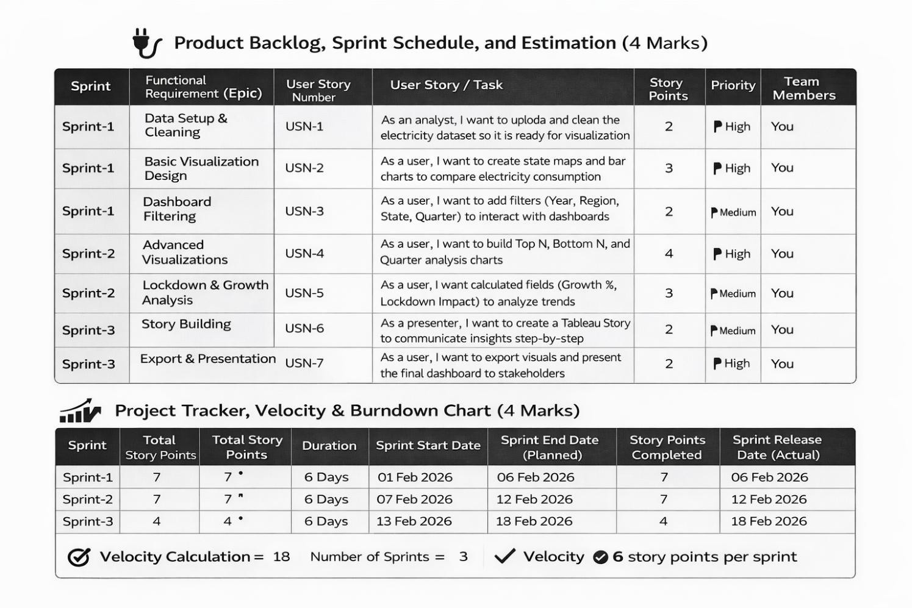
PERFORMANCE TESTING :

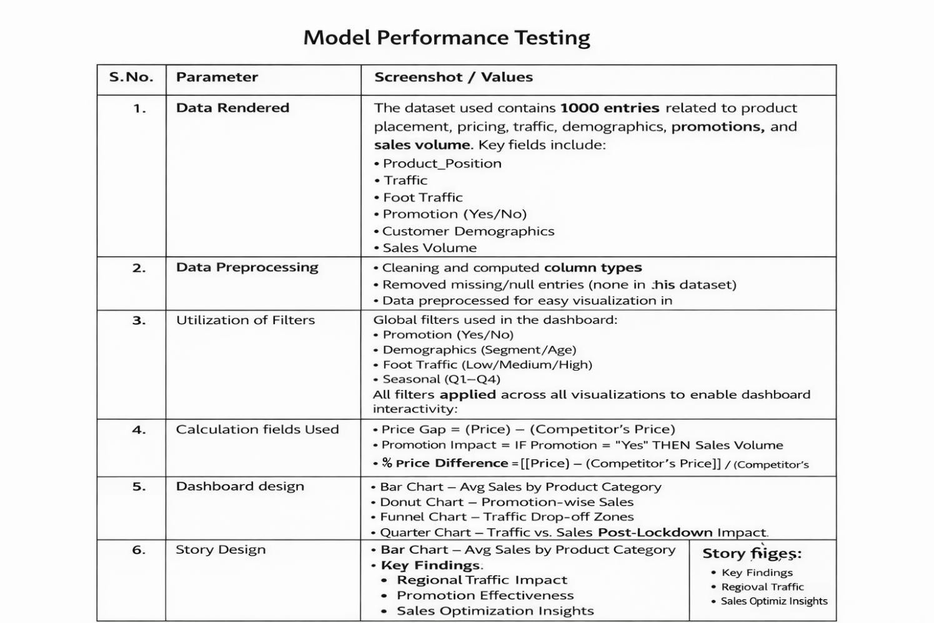

6 RESULTS :

a Output Screenshots:
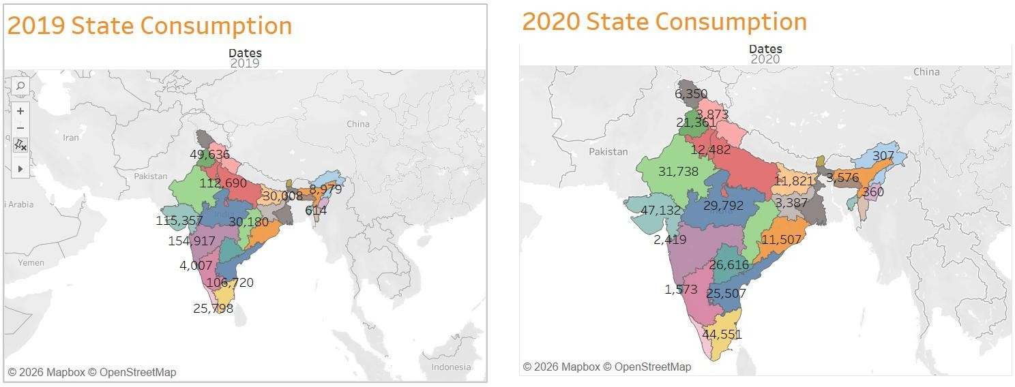

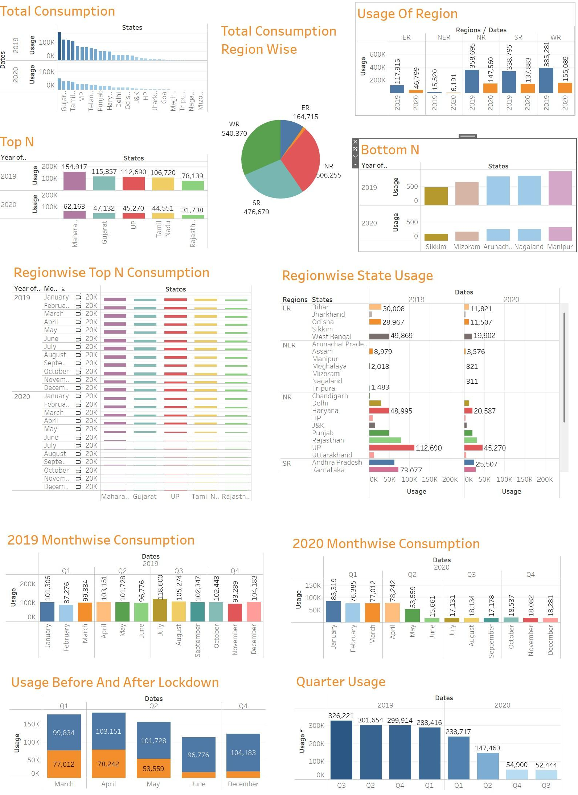

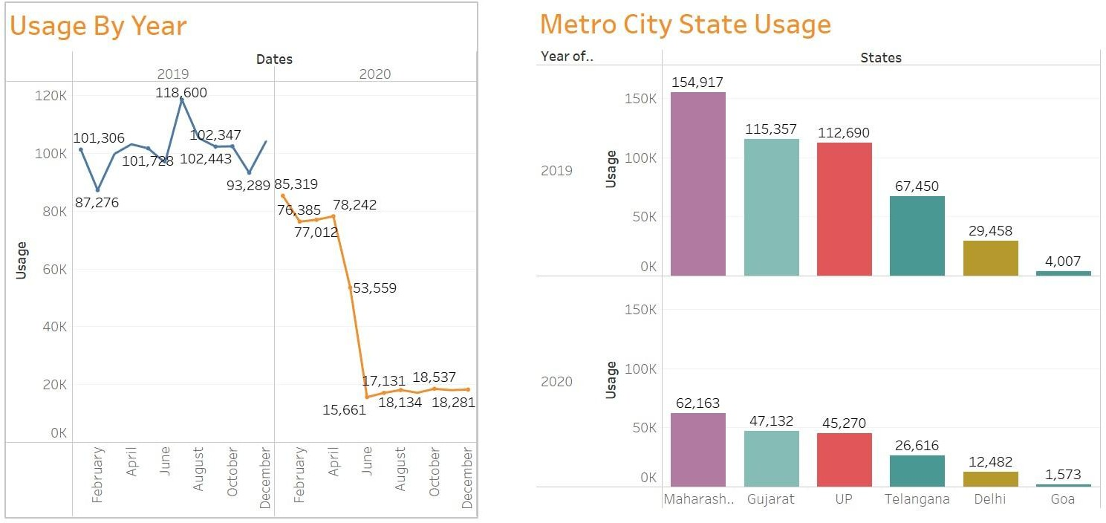

Disadvantage Description

- Static Data Source

- No Predictive Capabilities

- Limited Automation
- Requires Tableau Familiarity for Editing
- No Backend Storage for Historical Dashboards

CONCLUSION:
Since the dataset is CSV-based, it lacks real-time data updates. Manual uploads are required for each update cycle.
The current solution is descriptive, not predictive. It identifies patterns but doesn’t forecast future trends.
Without integration to live data sources (e.g., APIs, databases), it cannot support automated, continuous data refresh.

While the dashboard is easy to use, editing charts or building new visuals requires knowledge of Tableau.
Tableau Public does not support complex versioning or change-tracking unless hosted in Tableau Cloud/Server.

This project, “Plugging into the Future – Electricity Consumption Analysis Using Tableau,” successfully demonstrates how electricity consumption data — when visualized effectively — can uncover meaningful insights that directly support energy planning and policy decisions. By transforming a static electricity consumption dataset into a fully interactive and filterable Tableau dashboard, the project empowers energy stakeholders to:
- Identify which states and regions have the highest electricity demand.
- Understand the impact of seasonal variations and lockdown periods on power consumption.
- Compare yearly and quarterly trends to detect growth patterns and demand shifts.
- Highlight hidden insights that were previously difficult to interpret using traditional spreadsheets or static reports.
The dashboard offers a user-friendly and visually intuitive interface that supports real-time filtering, multiple chart types (e.g., maps, bar charts, line charts, pie charts), and a structured story presentation to communicate findings clearly. It serves as a valuable decision-support tool for:
- Energy department officials planning infrastructure development
- Policymakers designing efficient power distribution strategies

- Analysts monitoring consumption patterns and regional demand
Through structured project planning, sprint-based execution, and iterative dashboard design, the solution achieved its key objectives:
- Enhanced data visibility
- Faster and evidence-based decision-making
- Reduced dependence on manual analysis
Although there are limitations — such as reliance on historical data and absence of predictive forecasting — the project establishes a strong and scalable foundation for future enhancements, including real-time integration and advanced analytics.
In conclusion, this project validates that visual data storytelling using Tableau is a powerful tool for improving transparency, efficiency, and strategic decision-making in electricity consumption management.

FUTURE SCOPE:

Real-Time Data Integration
Integrate live electricity consumption feeds from smart meters, energy grids, or government databases.
  - Use Tableau live data connections or APIs to automatically update dashboards without manual uploads.

Predictive Analytics and Machine Learning
Incorporate machine learning models (using Python or R) to: o Forecast future electricity demand based on historical trends. o Predict peak load periods and seasonal demand spikes.
- Apply clustering techniques to group regions with similar consumption patterns for optimized distribution planning.

Cloud Deployment for Collaboration
Deploy the dashboard on Tableau Cloud or Tableau Server for centralized access.
  - Enable energy departments, policymakers, and analysts to collaborate using a unified data source.

Deeper Segmentation and Personalization
  - Extend analysis to sector-wise consumption (Residential, Commercial, Industrial).
  - Add deeper time-based filters such as weekday vs. weekend or hourly demand patterns.

Historical Data Versioning
Implement year-over-year and quarter-over-quarter comparison features.
Add toggle options to compare pre-lockdown, lockdown, and post-lockdown electricity usage.

Dashboard-as-a-Service Model
Offer the dashboard as an analytics solution for electricity boards or smart city projects. Provide customizable versions for different states or energy departments with integrated realtime data.

APPENDIX:

Dataset Link - https://drive.google.com/file/d/1XDxHSKwHBM-VNf- 6sz_406Y0e7MJRrAd/view?usp=drivesdk
GitHub - https://github.com/mounika7759/Plugging-into-the-Future-An-Exploration-of-Electricity-Consumption-Patterns-Using-Tableau
Project Demo Link-
https://drive.google.com/file/d/1P45gaE4HNv9seE2aBw5R92MSjHIjlW8b/view?usp=drivesdk

